A1038-MEX-Jaguar-Mortar-Hallucinogenic Compounds-Maya-Pre Classic-300 CE

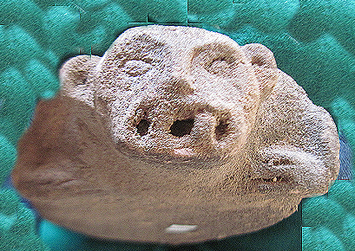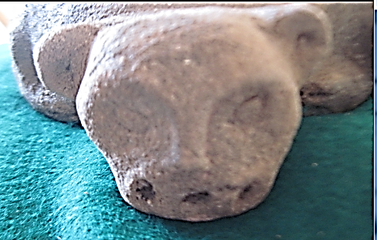 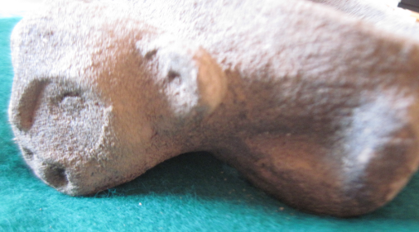

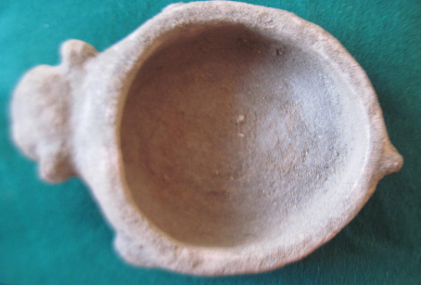 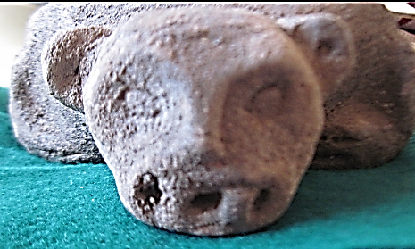

**Case no.: 14**

**Accession Number:**

**Formal Label:**

**Display Description:**

**LC Classification:**

**Date or Time Horizon:**

**Geographical Area:**

**Map:**

**GPS coordinates:**

**Cultural Affiliation:**

**Media:**

**Dimensions:**

**Weight:**

**Condition:**

**Provenance:**

**Discussion:**

**References:**